ABERDEEN SANDS
HELPLINE (0870) 7606649
EMAIL: help@aberdeen-sands.org
WEBSITE: www.aberdeen-sands.org
ADDRESS: PO BOX12113
ABERDEEN AB16 9DX
TWITTER: @SANDSABERDEEN
FACEBOOK@ABERDEENSANDS

Charity Number 299679 SCO 42789

NEWSLETTER: April 2021

CHAIRPERSON: Fiona RUBISLAW LIASON: Sandra
SECRETARY: Susan MEMORY POCKETS: Marjory
TREASURER: Heather WEBSITE: James and Jen M TELEPHONE ROTA: Fiona ANNIVERSARY CARDS: Karla
BEFRIENDER CO-ORDINATOR: Fiona

We hope you are bearing up to the limitations still in place of lockdown which still makes it difficult for all especially bereaved parents getting support from friends and family. Hopefully things will change slightly soon. We are hopeful that we can return to face-to-face meetings when government restrictions allow.
Support Meetings

We still have our messenger page for parents to support each other and a Facebook Private page for those who wish to get support from the Next Pregnancy After a Loss meeting, whilst we are unable to host face to face meetings.

We have zoom meetings on the dates that our meetings would normally take place. The dates are at the end of this newsletter.
If you would like more information on either group please email help@aberdeen-sands.org.

Support For Dads

Cardiff and Newport SANDS are running online Dad’s meetings via zoom which last month was well attended and they welcome Dads from around the UK. For more information, please email cardiffsands@hotmail.co.uk and they can give you the zoom meeting details.
Christmas Service
Due to face-to-face restrictions we had a pre-recorded Aberdeen SANDS Christmas Service this year online. We would like to thank the hospital chaplains Mark and Jarod, the parents Susan, Catherine, Fiona and Lynn and Andy Brown from AB Creative Aberdeen for producing the prerecording of the service. It was a lovely service and we had well over 100 viewings on our you tube page.

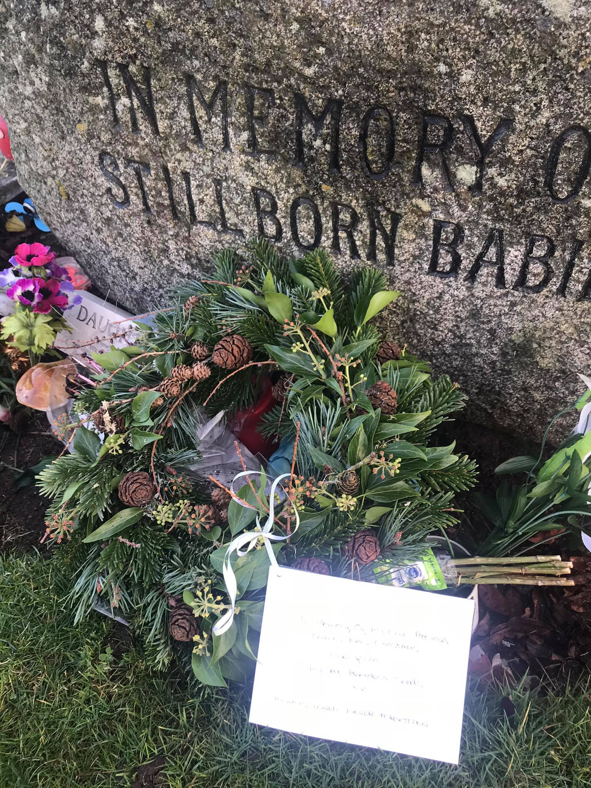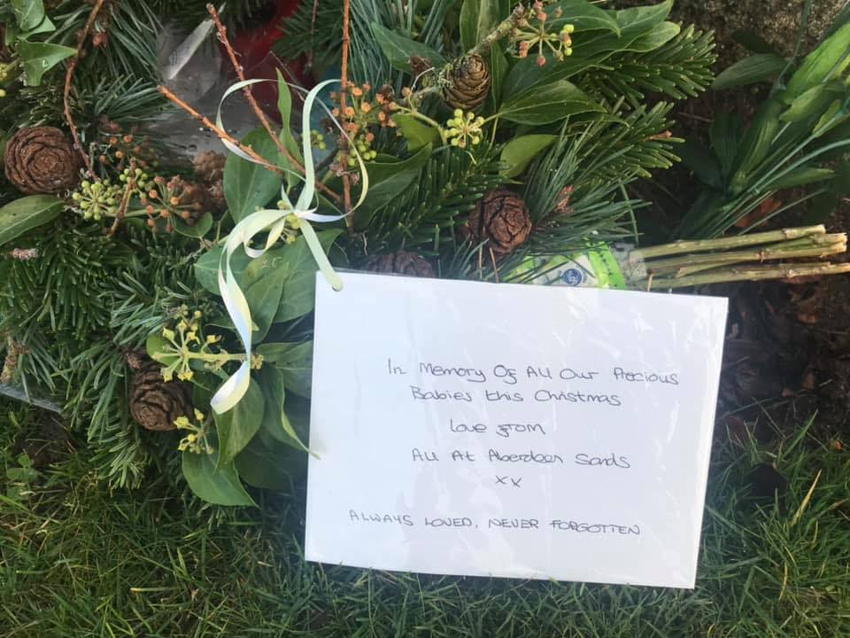
Christmas Wreaths
Thank you to Caroline of Forbes Flowers Alford who donated three lovely Christmas wreaths which we placed at each of the three memorials Hazelhead Baby Garden, Aberdeen Crematorium and Trinity Cemetery. It is much appreciated Caroline.

Rubislaw Ward, Aberdeen Maternity Hospital and Doctor Grays’s Elgin
We continue to support the Rubislaw Ward and Doctor Gray’s in Elgin with items such as memory boxes, memory pockets, toiletry bags, SD cards, printer paper, children’s books and ink, for example.
We purchased 4 new cooling mats for the cuddle cots and a new Schnuggle Moses basket for Rubislaw ward which complies with infection control regulations.
They are invaluable as it means bereaved parents can spend more time with their precious babies.
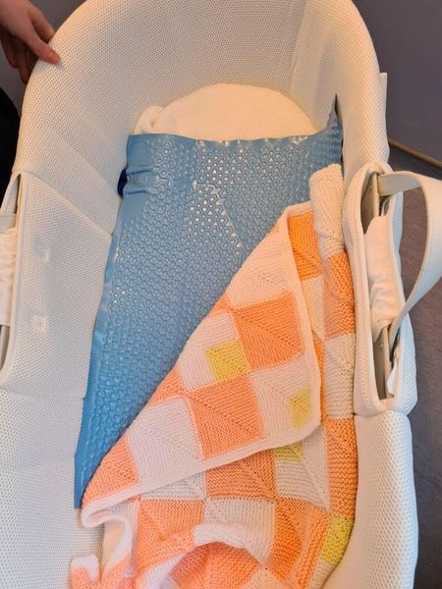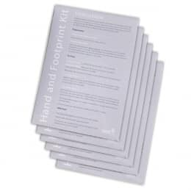
We also donated Hand and Footprint Kits to
Neo-natal Unit at Aberdeen Maternity.
Thank you to all who fundraised or donated to us throughout last year as without your support we would not be able to provide these items to the ward

We received the following thank you from Aberdeen Maternity Neo Natal Unit.

The kits have been used for memory making which is essential for the families on their journey through NNU especially at this time. We really appreciate Sands in providing these kits
Quiz Night
We had a fun quiz night at the end January, which was attended online by twelve or so families, thank you to Sandra for organising. It was a social event for parents to get together virtually. Well done to the winners and hopefully this can be repeated.

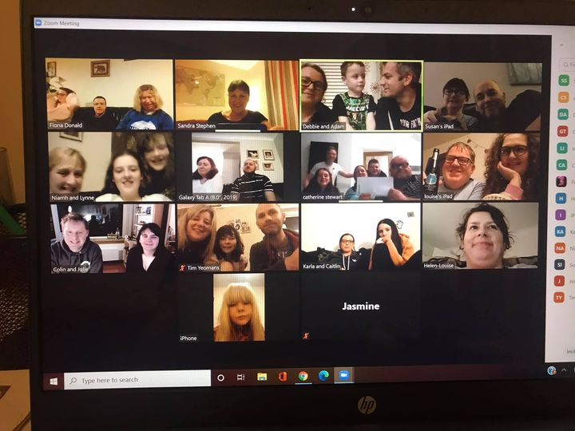

YPI
Some pupils from Westhill Academy have selected Aberdeen SANDS as their charity to find out more about and perform a presentation in front of the school. The girls are still working on this and we wish them all the best for the competition and thank you for choosing SANDS as your charity.

Hazelhead Baby Cemetery Memorial Garden
The garden has been tidied up and the crocus bulbs are coming through in the tubs.
We thought might be nice to brighten the garden up with some painted stones so we wondered if any youngsters or adults would like to paint some stones so they can be placed at the garden. Feel free to place them yourselves, if possible, not in the flower bed, but if you don’t feel able to visit the garden let me us know
When the painted stones are laid however we hope they are not moved, but sometimes this does happen.
To get to the Hazelhead Baby garden turn up the Aberdeen Crematorium road turn first left along the bottom of the graveyard. Park in the car park and you will see the wall from the Baby Garden in front of you.

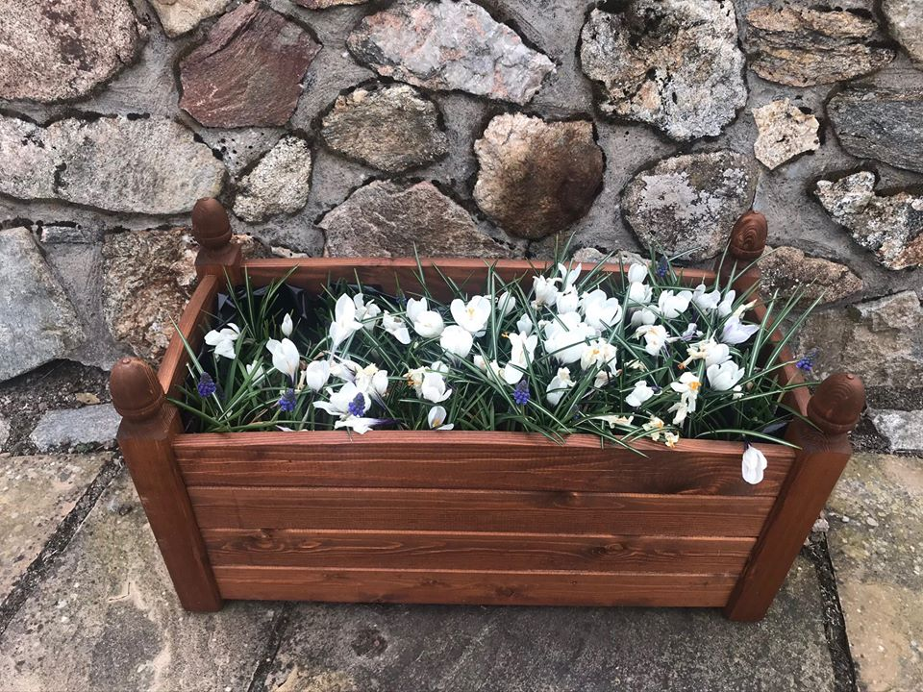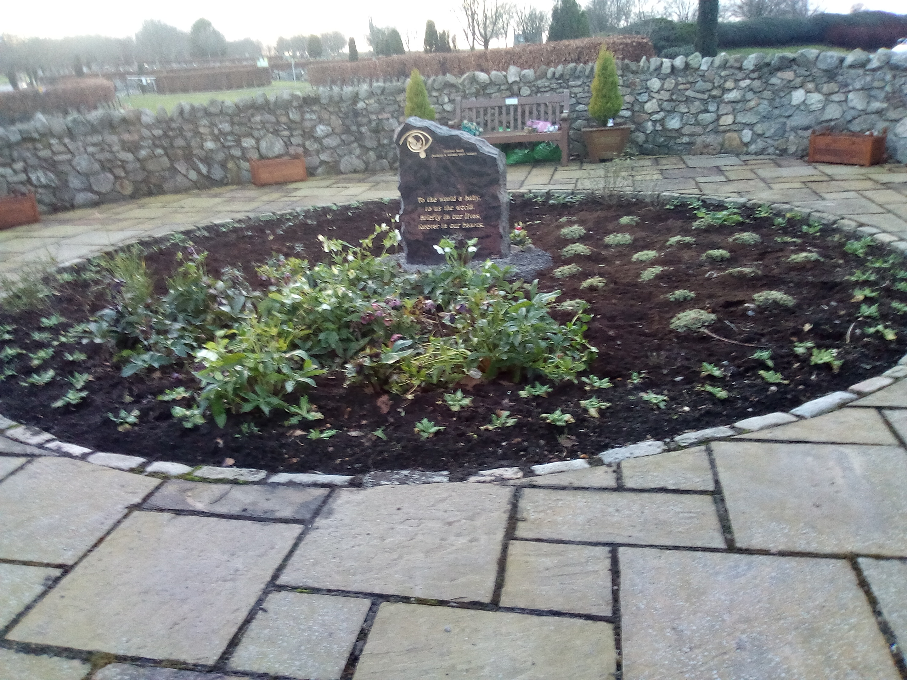
Baird Family Hospital
The construction of the new hospital is underway, the first concrete was poured in January and in February the piling work continued on the Baird site (heavy posts installed to support the foundations of a building).
Some of our committee resumed our ‘working together’ with Gail from the Baird project team and our activities will take another step forward this year. There is to be a big virtual launch at the end of April.

Maternity Voices Partnership
The committee now works with focus groups in Peterhead, Inverurie, Moray and Aberdeen with SANDS still involved and Fiona is attending both the local Aberdeen group which meets every two months and the larger Grampian overall group.
If any parent or family member has any feedback, they would like taken to the MVP committee, or if they would like more information about attending meetings, please email help@aberdeen-sands.org Experiences from service users are valuable so they can contribute to the development of local maternity care.

Bereavement Training For Professionals
Bereavement Training face to face has been postponed at present, however there are webinars available for professionals, for more information email
help@aberdeen-sands.org and we will put you in touch with the training coordinator. Fiona took part in a session and recommends them to any health professionals or those caring for bereaved parents.

Scottish Steering Group
The Scottish Steering group meets online at present due to restrictions every two months or so, where members of all the Scottish groups come together, to look at how best to support bereaved parents and improve bereavement care throughout Scotland.

National SANDS Befriender Zoom Meetings and Facebook page
Befrienders are encouraged to attend online meetings and join a Befriender Facebook page with others from around the UK, where ideas and support being offered can be shared.

RGU Student Midwife Curriculum Review Group
Fiona attends monthly online meetings, assists with the creation of new courses as a past service user and is a member of the Maternity Voices Partnership in line with the ‘Best Start’.
The course is up for validation in May to which a number service users will be interviewed. In December and February surveys were issued to service users asking what should be included in the curriculum and the qualities of a good midwife. There were many responses so thank to those of you took part in this.
RGU Second year Midwife Student Bereavement Training
Sonia and Fiona have had a pre meeting regarding Sonia’s talk ‘A Parent’s Perspective’ to 2nd year student midwives. The talk will be delivered online to students in April. The students will also receive Sands leaflets and a copy of Guidelines for Professionals.

Aberdeenshire Child Bereavement Group
Online calls are held every couple of months. There are about ten charities and groups attending who support bereaved children in Aberdeenshire and the city. This is really useful sharing the support available for children and families in this area.

Anniversary Cards 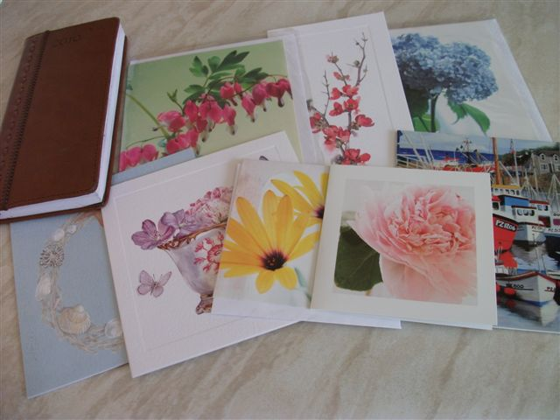

Should you wish a card on the anniversary of your baby's death, please send your name, address along with your baby's name and date of passing to help@aberdeen-sands.org.
Please be assured that under GDPR rules your details will be stored securely and not passed on to anyone else.

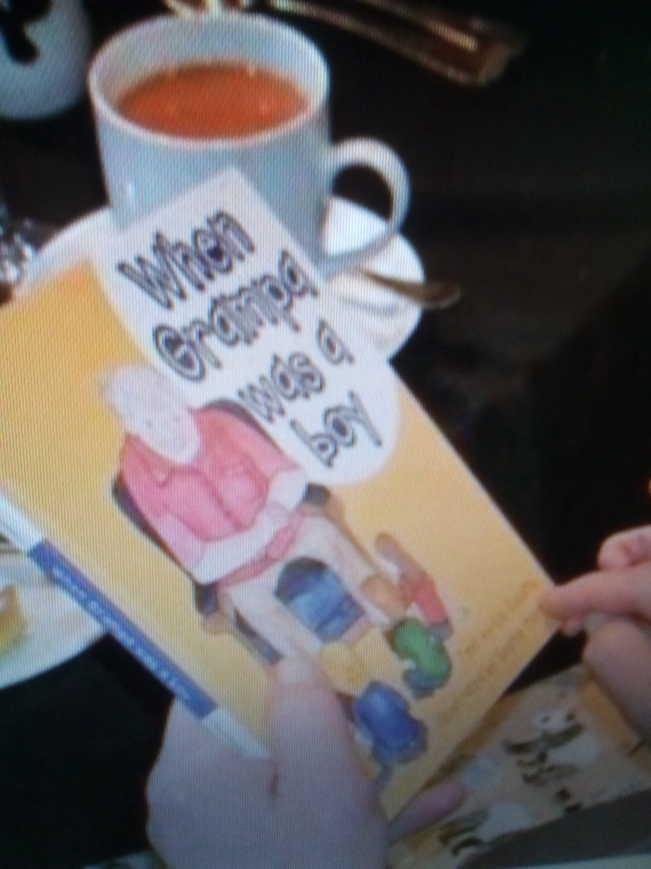
Book Fundraiser
A book called ‘When Grampa was a Boy’ has been published by one of our bereaved grandparents in memory of her beautiful granddaughter Gail. Liz is helping raise money with the sale of the book for SANDS. For more information on this children’s book for age 2 to 6 years please email lizcoutts@aol.com.

FUNDRAISING
If any of you feel challenged to fundraise for SANDS in Scotland in 2021, below is some of the events taking place.

Kiltwalk Scotland 23–25th April 2021
Anyone fancying taking part in any Kiltwalk inspired challenge, go for a walk (of any length) cycle, jump on a trampoline or even a scavenger hunt. You decide on your challenge and as long as you are raising funds for SANDS.. anything goes. The money raised goes to SANDS SCOTLAND which provides memory boxes, heart keyrings and bereavement books to bereaved parents in Scotland.
Please sign up on www.sands.org.uk/kiltwalk21.

Edinburgh Marathon Festival 29 – 30 May 2021
Tough Mudder Scotland – 3 and 4 July 2021
Men’s 10k August – October 2021
Women’s 10k August – October 2021
Scottish Half Marathon and 10k Sunday 19 September 2021
Great Scottish Run Half Marathon and 10k Glasgow Sunday 3 October 2021 TBC
Supernova Run October – November 2021
Fairer Aberdeen Coronavirus Pandemic Hardship Fund
We were pleased to receive a Grant for £150.00 from the Fairer Aberdeen Coronavirus Pandemic Hardship Fund. This will pay for our online support on zoom calls for the next few months and the postage of support books to bereaved parents and Families.
Thank you to the selection committee for choosing our group as one of the charities to receive funding, it is greatly appreciated.
DONATIONS
£219.00 from Susan M who took part in 300,000 steps for October in memory of Harrison in his birthday month
£500.00 donated from the Aberdeen Etsy Team from there Christmas event and raffle

£25.00 from Louise in lieu of Christmas cards.

£103.00 from Lindsay and Cat who ran a 'Wheel of Fortune' quiz live on Facebook every Friday evening at 8pm for a bit of light entertainment during lockdown.
A parent called Kirsty won and asked for the money to come to our group, thank you.
£500.00 from Alba North Welfare committee nominated by John.
£40.00 from Rosemary and Bob for their nieces Gemma and Sarah’s birthdays daughters of Fiona and George.
£1026.00 was raised by Katie in memory of Grace taking part in Love me to the moon and back 3x 50k challenges for National SANDS.
£690.00 from Rita for fundraising for National SANDS undertaking Challenge 14.
Like many other charities due to COVID donations and fundraisers are much less than in previous years. If you would like to fundraise for us please contact us at help@aberdeen-sands.org or set up a fundraising page at https://sands.enthuse.com/sandsaberdeen/profile .
Thank you to all those who have donated through this medium who we haven’t thanked above and who have fundraised for National SANDS.

CONGRATULATION ON THE SAFE ARRIVAL OF
Jessica born 28th December to Johnathon and Ariane weighing 6lb 5.5oz little sister to the late James.
Alexander James born 8th February to Lynn and Dougie weighing 7lb 14.5oz little brother to Eilidh and the late Lachlan.
Forthcoming Meetings-All Welcome

SHETLAND SANDS SUPPORT MEETINGS
For more information call 07341945028 or email admin@shetlandsands.co.uk

MAIN SUPPORT MEETINGS
On zoom until we can meet face to face
MAIN SUPPORT MEETING
Thursday 1st April 8.00-11.00pm
Thursday 6th May 8.00-11.00pm
Thursday 3rdJune 8.00-11.00pm
Thursday 1st July 8.00 -11.00pm
Thursday 5th Aug 8.00-11.00pm

NEXT PREGNANCY AFTER A LOSS MEETINGS
On zoom until we can meet face to face.
Wednesday 14th April 8.00-11.00pm
Wednesday 19th May 8.00-11.00pm
Wednesday 16th June 8.00-11.00pm
Wednesday 14TH July 8.00-11.00pm
Wednesday 18th Aug 8.00-11.00pm

MORAY SANDS SUPPORT MEETINGS
Due to COVID restrictions Moray Sands are not hosting meetings but any parents are welcome to join the Aberdeen Support Meetings on zoom.

Healthcare Chaplaincy Dates

East Chapel Aberdeen Crematorium (all at 10.00am) for early miscarried babies

Wednesday 23rd June
Wednesday 22nd September
Wednesday 8th December

SANDS Christmas Service Chapel ARI Sunday12th December 2021

10.30am Quiet Service & 11.15am Family Service
(times to be confirmed)

