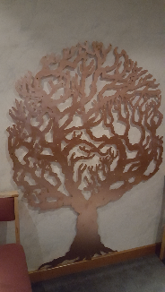
Application for memorial tree leaf.
If you would like to request a leaf for our memorial tree, please can you fill in the form below and return it to Rubislaw Ward or email it to our address below.
Name and address

Telephone number

Email address

Inscribing details for leaf
(Baby name - limited to
72 characters including spaces
with short date - NOTE that 72 is the number of letters, not words)
If your baby does not have a name you can have Baby Smith for e.g.
Bereavement Support Team
gram.bereavementsupportmaternity@nhs.scot
Mobile: 07989 718717

Once we receive your application we will arrange for your leaf to go for inscribing, it can take a few weeks for this to be returned to us. There is no cost for the leaf.
Once we have your leaf we will contact you to let you know it is ready to be placed on the tree.
Your leaf may stay on the memorial tree for as long as you wish and will not be removed unless you request it. The bereavement team will then remove it and contact you for return so that you may keep this as an everlasting memento.
**Please advise us if any of the above contact details change so that we can ensure your leaf is
safely returned to you.

For bereavement team use
Date leaf requested | Date returned to Staff | Date attached to tree | Date applicant contacted for return | Date returned to applicant

